**Module (JQuery Basic, Effects & Advanced)- 5**

**Q. What is JQuery?**

🡪 JQuery is a small, light-weight and fast JavaScript library.

It is cross-platform and supports different types of

browsers. It is also referred as write less do more, because

it takes a lot of common tasks that requires many lines of

JavaScript code to accomplish, and binds them into

methods that can be called with a single line of code

whenever needed. It is also very useful to simplify a lot of

the complicated things from JavaScript, like AJAX calls

and DOM manipulation.

**Q. How to Apply CSS Using JQuery, How to Add Class**

**And Remove class in JQuery , JQuery Animation?**

🡪

**1)** **CSS Using JQuery Example :-**

<!DOCTYPE html>

<html lang="en">

<head>

<meta charset="UTF-8">

<meta name="viewport" content="width=device-width, initial-scale=1.0">

<script src="https://code.jquery.com/jquery-3.7.1.js" integrity="sha256-eKhayi8LEQwp4NKxN+CfCh+3qOVUtJn3QNZ0TciWLP4=" crossorigin="anonymous"></script>

<title>Document</title>

</head>

<body>

<div id="demo"> CSS USING JQUERY.</div>

<script>

$(document).ready(function(){

$("#demo").css("color","black")

$("#demo").css("background-color","yellow")

$("#demo").css("font-family","Verdana")

$("#demo").css("font-size","20px")

$("#demo").css("border","2px solid black")

$("#demo").css("padding","10px")

$("#demo").css("height","50px")

$("#demo").css("width", "200px")

$("#demo").css("text-align","center")

})

</script>

</body>

</html>

**OUTUT :-**

**2 )** **Add Class and Remove Class Using JQuery**

**Examples :-**

**🡪 Add Class**

<!DOCTYPE html>

<html lang="en">

<head>

<meta charset="UTF-8">

<meta name="viewport" content="width=device-width, initial-scale=1.0">

<script src="https://code.jquery.com/jquery-3.7.1.js" integrity="sha256-eKhayi8LEQwp4NKxN+CfCh+3qOVUtJn3QNZ0TciWLP4=" crossorigin="anonymous"></script>

<title>Document</title>

<style>

.one {

font-family: Verdana, Geneva, Tahoma, sans-serif;

font-size: 25px;

font-weight: bold;

color: red;

}

</style>

</head>

<body>

<p> Lorem ipsum dolor sit amet consectetur adipisicing elit. Reprehenderit, impedit.</p>

<p> Lorem ipsum dolor sit amet consectetur adipisicing elit. Reprehenderit, impedit.</p>

<button id="button"> ADD </button>

<script>

$(document).ready(function(){

$("button").click(function(){

$("p:first").addClass("one");

})

})

</script>

</body>

</html>

**OUTPUT : -**

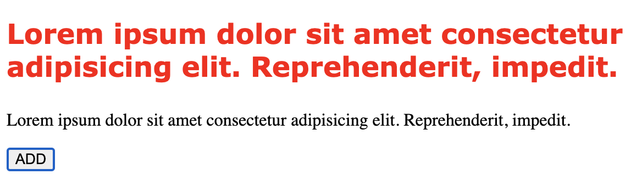

**🡪 Remove Class**

<!DOCTYPE html>

<html lang="en">

<head>

<meta charset="UTF-8">

<meta name="viewport" content="width=device-width, initial-scale=1.0">

<script src="https://code.jquery.com/jquery-3.7.1.js" integrity="sha256-eKhayi8LEQwp4NKxN+CfCh+3qOVUtJn3QNZ0TciWLP4=" crossorigin="anonymous"></script>

<title>Document</title>

<style>

.one {

font-family: Verdana, Geneva, Tahoma, sans-serif;

font-size: 25px;

font-weight: bold;

color: red;

}

</style>

</head>

<body>

<p class="one"> Lorem ipsum dolor sit amet consectetur adipisicing elit. Reprehenderit, impedit.</p>

<p> Lorem ipsum dolor sit amet consectetur adipisicing elit. Reprehenderit, impedit.</p>

<button id="button"> REMOVE </button>

<script>

$(document).ready(function(){

$("button").click(function(){

$("p").removeClass("one");

})

})

</script>

</body>

</html>

**OUTPUT : -**

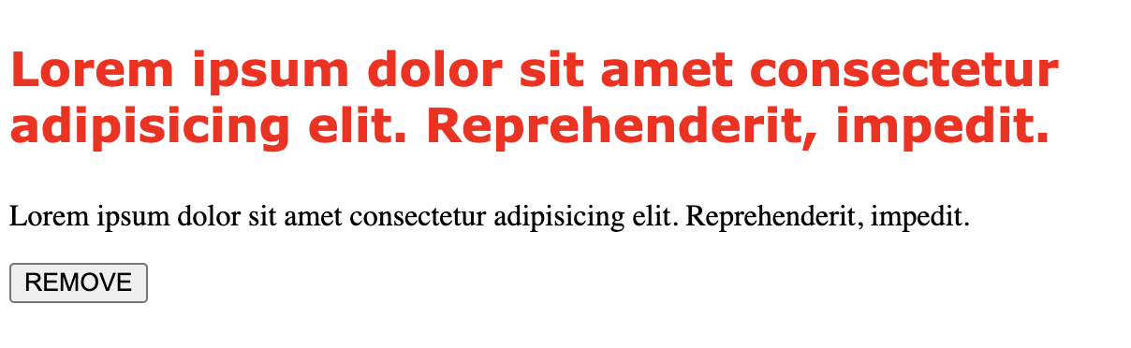

**🡪 JQuery Animation**

<!DOCTYPE html>

<html lang="en">

<head>

<meta charset="UTF-8">

<meta name="viewport" content="width=device-width, initial-scale=1.0">

<script src="https://code.jquery.com/jquery-3.7.1.js" integrity="sha256-eKhayi8LEQwp4NKxN+CfCh+3qOVUtJn3QNZ0TciWLP4=" crossorigin="anonymous"></script>

<title>Document</title>

<style>

#one {

height: 200px;

width: 200px;

background-color: green;

position: relative;

color: white;

}

</style>

</head>

<body>

<div id="one">

<p> Lorem ipsum dolor sit amet consectetur adipisicing elit. Voluptates, quos.</p>

</div>

<br>

<button id="button">ANIMATION </button>

<script>

$(document).ready(function () {

$("#button").click(function () {

$("#one").animate({ "left": "300px" },4000);

$("#one").animate({ fontSize: "40px" },3000)

$("#one").animate({ "left": "300px" },4000)

})

})

</script>

</body>

</html>

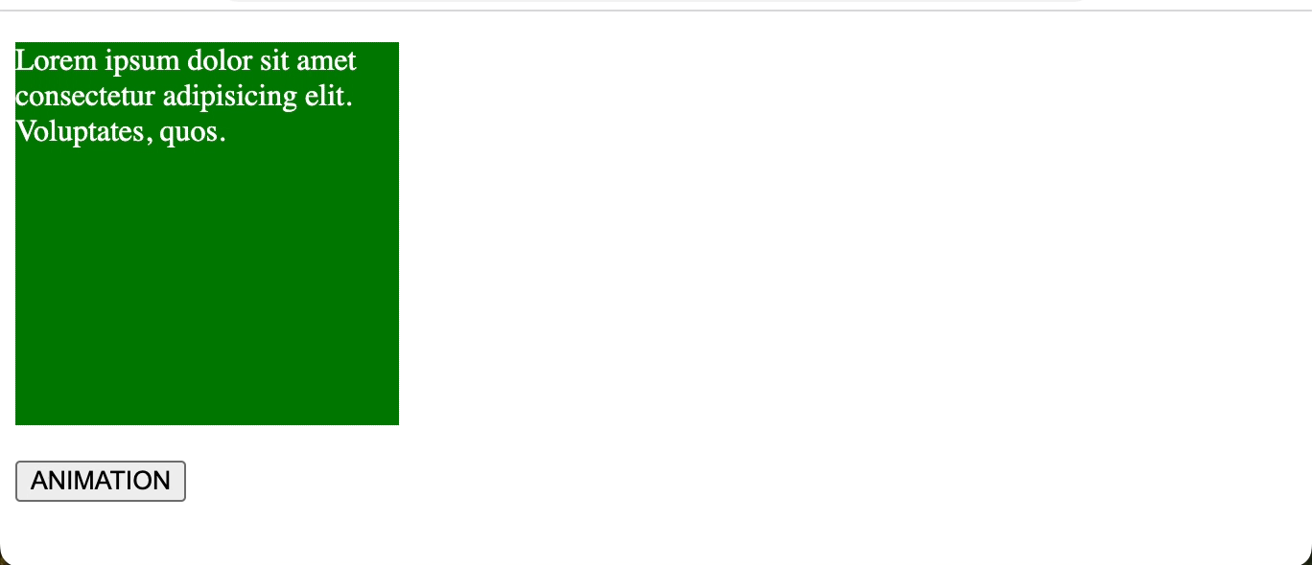**OUTPUT : -**

**Q. How to Create Slider with animation?**

**🡪**

<!DOCTYPE html>

<html lang="en">

<head>

<meta charset="UTF-8">

<meta name="viewport" content="width=device-width, initial-scale=1.0">

<script src="https://code.jquery.com/jquery-3.7.1.js" integrity="sha256-eKhayi8LEQwp4NKxN+CfCh+3qOVUtJn3QNZ0TciWLP4=" crossorigin="anonymous"></script>

<title>Document</title>

<style>

#slide1, #slide2 {

padding: 5px;

text-align: center;

background-color: rgb(207, 255, 207);

border: 1px solid lightgreen;

}

#slide2 {

padding: 50px;

display: none;

}

img {

width: 50%;

height: 50%;

box-shadow: rgba(50, 50, 93, 0.25) 0px 50px 100px -20px, rgba(0, 0, 0, 0.3) 0px 30px 60px -30px, rgba(10, 37, 64, 0.35) 0px -2px 6px 0px inset;

}

</style>

</head>

<body>

<div id="slide1"> Click Here...! </div>

<div id="slide2">

<img src="/Users/arnavpandav/Downloads/mountainskies.jpg">

</div>

<script>

$(document).ready(function(){

$("#slide1").click(function(){

$("#slide2").slideToggle("slow");

})

})

</script>

</body>

</html>

**OUTPUT : -**

